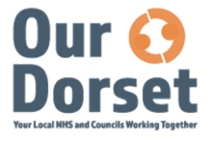
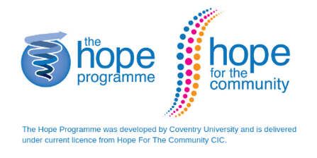

What is HOPE?
HOPE stands for Help Overcoming Problems Effectively.
Help & Care are coordinating the launch of HOPE in Dorset, alongside our NHS and community colleagues. We are very excited to be rolling out this programme which has been so successful across the country.
The programme helps to focus on the person and not solely on a long-term condition or life changing event. It helps people to discover new strengths and rediscover old ones to keep themselves well. It also aims to boost self-confidence and resilience, to help cope better emotionally, psychologically and practically with any condition.
The Hope Programme provides you with the knowledge, skills and confidence to cope with many of life’s challenges, frustrations, fears and isolation. The courses empower people to manage their health and wellbeing and to flourish in their working and personal lives.
The courses are based on positive psychology, mindfulness and cognitive behavioural therapy and rooted in research evidence.
The course will help you to:
- Feel more able to support and share your experiences with others to help you feel less isolated.
- Feel reassured and able to recognise your own potential and enhance your happiness and quality of life.
- Feel more confident in dealing with emotional issues such as: anxiety, anger, depression and uncertainty.
- Increase your ability to handle stressful situations.
- Discover how to use relaxation techniques to refresh your mind and body.
- Learn how to make plans and achieve goals that can help you make changes for the better.
- Use the skills from the course to improve and self-manage your life.
About the sessions
It is a 6 week programme with each weekly session lasting for about
2 ½ hours. This might be in person or on-line.
It is run by trained HOPE facilitators: health and social care professionals as well as volunteers. Once you have completed the course you may wish to become a facilitator yourself.
We aim to have between 8 – 12 people on each course. Time on the course will be spent in discussions, fun group activities and sharing information. There will also be some suggestions and ideas to try between each session to build your confidence.

On each course you will find:
- A warm, friendly atmosphere
- Support when you need it
- General small group discussions on topics such as:
- Managing fatigue
- Getting more active
- Feeling good
- Goal setting
- Gratitude Diary
- Managing stress
- Communication

